Honors ELA
Year-at-a-Glance (DRAFT)
20234-2025
Module A  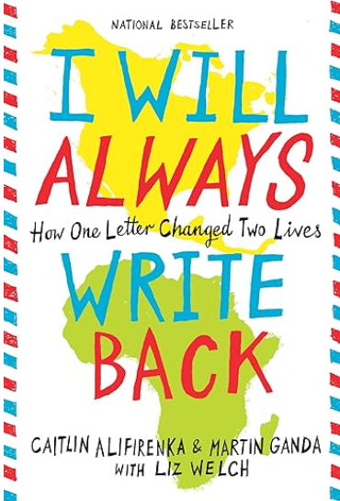  August 12-September 13  24 Days | Connecting Cultures  Essential Question: How can communication and empathy bridge cultural divides and impact individual lives and communities?  Reading Focus: I Will Always Write Back – BEST, “9/11 Address to the Nation”, excerpt from A Long Walk to Freedom - BEST  Writing Focus: Narrative | Focus Benchmarks  ELA.8.R.1.1  ELA.8.R.1.2  ELA.8.R.1.3  ELA.8.R.2.4  ELA.8.R.3.1  ELA.8.R.3.3  ELA.8.R.3.4  ELA.8.C.1.2
Module B    September 16-October 11  19 Days | Spies, Lies, & Allies  Essential Question: How does deception and alliance shape the outcomes of conflicts?  Reading Focus: The Enigma Girls, An excerpt from “The Secrets and Lies of Cold War Spies”, “Courage Under Fire: How Ex-CIA Officer Nic McKinley Dodged Bullets, Spies, & Terrorists”, "How Nations Have Spied from the Sky”, “Benedict Arnold: Two Sides of a Bitter Coin”, “What Made Aldrich Ames Tick?”, “Involuntary Spies”, “On Spies”  Writing Focus: Argument | Focus Benchmarks  ELA.8.R.1.4  ELA.8.R.2.1  ELA.8.R.2.2  ELA.8.R.2.3  ELA.8.R.2.4  ELA.8.R.3.1  ELA.8.C.1.3
Module C  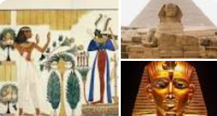  October 15-November 8  19 Days | Unraveling the Mysteries of Ancient Egypt  Essential Question: How do the cultural, technological, and social innovations of a civilization contribute to its survival and legacy?  Reading Focus: “Developing Civilizations in Ancient Egypt”, “Ancient Egyptian Dynasties”, “Egyptian Mummies”, “Tutankhamen, Anatomy of an Excavation” StudySync, “The Raven” BEST/StudySync, “Who Was Cleopatra?”, Excerpts from Stories from Ancient Egypt  Writing Focus: Expository  District Writing Assessment - Week of November 4 | Focus Benchmarks  ELA.8.R.1.2  ELA.8.R.1.4  ELA.8.R.2.1  ELA.8.R.2.2  ELA.8.R.2.3  ELA.8.R.2.4  ELA.8.R.3.4  ELA.8.C.1.4
Module D  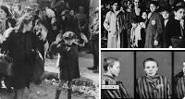November 11-December 20  24 Days | Facing Adversity (Book Clubs)  Essential Question: How do individual and collective choices during times of conflict reflect broader themes of humanity and morality?  Reading Focus: Book Clubs, “A Day Which Will Live in Infamy” BEST, “Nobel Prize Acceptance Speech – Elie Wiesel” StudySync, “Parallel Journeys” StudySync, Book Clubs TBD  Writing Focus: Expository/Argument | Focus Benchmarks  ELA.8.R.1.1  ELA.8.R.1.2  ELA.8.R.1.3  ELA.8.R.2.1  ELA.8.R.2.2  ELA.8.R.2.4  ELA.8.R.3.3  ELA.8.R.3.4  ELA.8.C.1.3  ELA.8.C.1.4
Module E  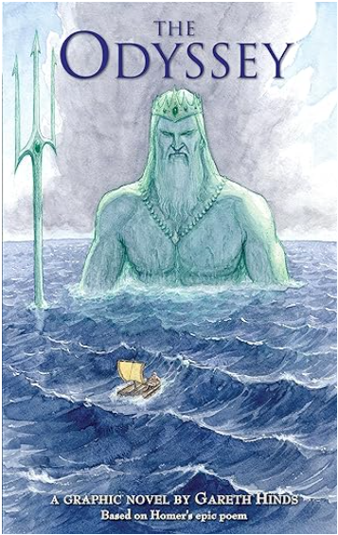  January 7 – February 7  23 Days | Epic  Essential Question: What factors inspire an individual to leave behind what is familiar and comfortable to experience what is new or difficult?  Reading Focus: The Odyssey (graphic novel), The Illiad – Book I & Book 19 StudySync/BEST, “Hephaestus Replaces Achilles Armor”, “Medea” StudySync/BEST, “The Betrayal”, excerpt from Antigone BEST/StudySync  Writing Focus: Expository | Focus Benchmarks  ELA.9.R.1.1  ELA.9.R.1.2  ELA.9.R.1.3  ELA.9.R.1.4  ELA.9.R.3.1  ELA.8.R.3.3  ELA.9.R.3.4  ELA.8.C.1.4
Module F  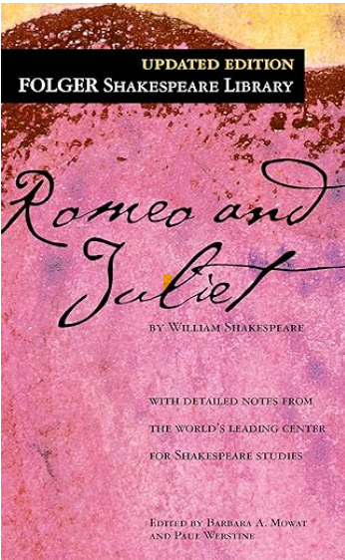  February 10 – March 14  24 Days | In the Name of Love  Essential Question: How does love, conflict, and fate help us understand relationships and the pressures we face?  Reading Focus: Romeo & Juliet BEST, “Shattering the Ivory Proscenium: The Impact of Black Actors in Shakespearean Roles”, “Making Shakespeare Relevant in the 21st Century”, “Archeologists find Prehistoric Romeo and Juliet”  Writing Focus: Argument | Focus Benchmarks  ELA.9.R.1.1  ELA.9.R.1.2  ELA.9.R.1.3  ELA.8.R.1.4  ELA.9.R.2.3  ELA.9.R.2.4  ELA.9.R.3.1  ELA.9.R.3.4  ELA.8.C.1.3
Module G    March 24 – April 25  23 Days | Power & Perspective  Essential Question: How do the influences of power and perspective shape our understanding of history?  Reading Focus: “Dangers of a Single Story” BEST, “Speech to the Troops of Tilbury” BEST, “Parsley” StudySync/BEST, “Letter from Birmingham Jail” StudySync/BEST, “I Have a Dream” StudySync/BEST, excerpt from Finding Manana: A Memoir of a Cuban Exodus – StudySync/BEST, Excerpt from Democracy in America StudySync/BEST, excerpt from The Prince StudySync/BEST  Writing Focus: Expository/Argument | Focus Benchmarks  ELA.8.R.1.4  ELA.9.R.2.1  ELA.9.R.2.2  ELA.9.R.2.3  ELA.9.R.2.4  ELA.9.R.3.1  ELA.9.R.3.4  ELA.8.C.1.3  ELA.8.C.1.4
Module H    April 28 – May 29  23 Days | The Great Unknown  Floating Five: Strategic Reading Days (prior to FAST PM 3)  Essential Question: What insights can be gained from the adventures of individuals as they navigate into the unknown?  Reading Focus: A First Time for Everything (graphic novel), excerpt from The Call of the Wild StudySync/BEST, excerpt from The Hobbit StudySync/ BEST, “The Road Not Taken” StudySync/BEST, The Wright Brothers – BEST, excerpt from Swiss Family Robinson BEST, excerpt from The Adventures of Tom Sawyer - StudySync  Writing Focus: Narrative | Focus Benchmarks  ELA.8.R.1.1  ELA.8.R.1.2  ELA.8.R.1.3  ELA.8.R.1.4  ELA.8.R.2.1  ELA.8.R.2.2  ELA.8.R.2.3  ELA.8.R.2.4  ELA.8.R.3.1  ELA.8.R.3.4  ELA.8.C.1.2
*Benchmarks ELA.8.V.1.2, ELA.8.V.1.3, and ELA.8.R.3.2 are embedded in each module.

